Guard Your Hearts and Bodies from Demonic Influence
February 6, 2017

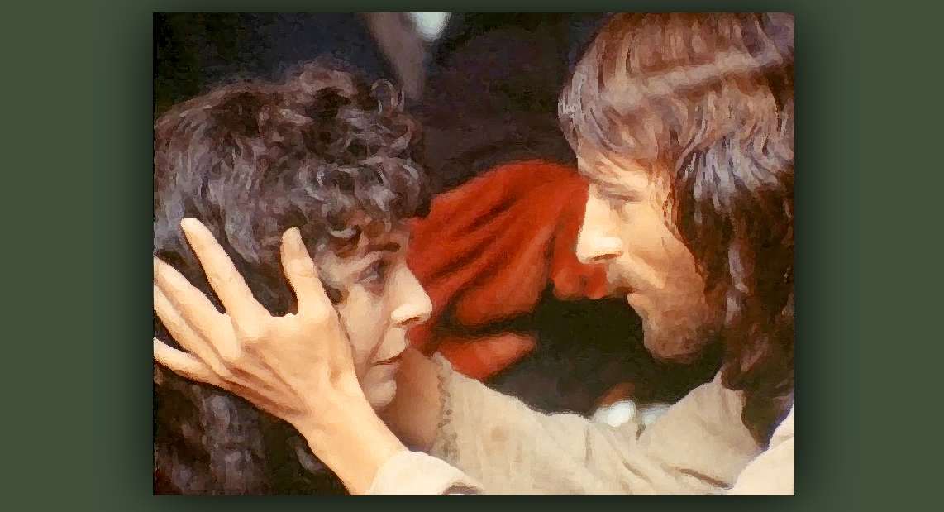
May the blessing of purity and a pure love for Our Savior be our reality, in spirit and in truth.

Well, my dear family, I have much to say to you today. During my communion service, President Trump was presented to me to pray for, and I sense he has a decision to make and needs to be saturated in Godly wisdom.

It doesn’t have to come with an evangelical buzz-word. Infused knowledge, knowledge and understanding from above, is what I sense he needs.

Interestingly, North Korea came up today and I pray that Our Lord will forestall any attempt by that enemy to attack our country. I am also praying that the President will see how dangerous it is to have our troops all over the world and not sufficient protection here in an 'unwalled continent living in peace.'

My heart is saddened by the slander against the President and his decisions and I pray for an end to the libelous media coverage of his office. And that people will begin to boycott the major media, because they will see they are working for the Elite whose agenda is to destroy America - something Obama came very close to succeeding at. Now he is wroth, because he has lost the seat of power, yet he never tires of finding a way to destroy our freedom.

And I would ask any of you, if you have any advice on how to get those bleeps off the telephone that come from the different news agencies - I don't want to have anything to do with those people. I want to unsubscribe from all of that. If you could let us know how to do that - let me know, please. 'Cause I'm really sick of this and I want them to know that I'm not going to be tuning in to them. Even though I wasn't tuning in before! They deserve to be boycotted. And the Lord has been trying to get our attention off the media for a long time, so this is something new. But for those of us who haven't quite extricated ourselves from the habit, I think that boycotting it will make an obvious statement, that the ratings have gone down and people aren't interested. They are not interested in listening to lies any more. They are losing viewers because of poison.

I wanted to mention - some of us are going through serious sufferings again and we will be until the 'monster' is caged. Judging from what the Lord said recently, 90 days from the date of his inauguration - that means June should be a turn-around month for America. And I am hoping and praying the corruption of the previous administration will be completely exposed to the public, so they can see how duped they’ve been by personalities, rather than their track record or performance.

Speaking of which, if they looked only at the hard facts they would see they’ve been played. One fact is…the stock market rose to a record-breaking high, thanks to some of the first measures President Trump has put into action. Not that we should judge things financially or by money, but that is an improvement for sure. And it's a sign of recovery in our nation.

What great things we can look forward to seeing when abortion is finally abolished on American soil, the way it is in Russia.

But, changing the subject, one of our prayer warriors had a word for us which I feel is very important to pass on to you. Guard your hearts.

She had a dream. It begins: "Guard Your Heart."
"The most important thing right now is to guard your heart. You need to guard your heart, because it is where all emotions grow, where all thoughts are stored. And where all of My graces come forth first, where I abide in you."

And I guess this is the Lord speaking to her.

"The heart is the most important organ of your body and in the spiritual world is also important. It can store LOVE, mercy, anger, freedom, bitterness, courage, or compassion." "

She continued, "As I hear the voice of the Lord and repeated everything that He was saying, my husband never woke up - and he's a light sleeper!”

So, that was a supernatural act in itself.

"But I was seeing in the spirit a very small, intense light going around every one of the flowers and a swirly metal thing touching them and releasing them into Earth. As they were coming down to Earth, He kept saying ‘Guard Your Heart.’ I saw how they came into each person in Earth that is a believer and came inside their hearts. I asked the Lord 'What is going on?'”

He said, "Look into your heart."

“I looked at my heart inside my body - the real thing. It has to be in the spirit, because I saw my heart. Plus, I was awake by them because of my voice, but with my eyes closed. When I was looking at my heart, I saw these flowers entering my body and covering my heart. They were white flowers, which are not seen in Earth, and they covered my heart. As they cover the heart, they change into white ivory incandescence - a box with a huge flower on top protecting and guarding my heart.

“He was still telling me to ‘Guard my Heart’.

"Family, all of the flowers and metal swirly things that were send to Earth last night were thousands upon thousands of them. We need to Guard our Hearts. All of you have some kind of box protecting your hearts right now. From what? I don't know.

"Maybe in prayer you can ask the Lord what kind of box He put in your heart last night and why do we need to guard our hearts? Maybe you already know. Maybe this is a confirmation to one of us of something you have been talking to the Lord about. But your heart has been GUARDED by the Lord."

Interestingly, this dream came on the heels of an experience one of our Heartdwellers had and I want to share this with you, because if this person had these experiences, others of you may also be having them. And I want to protect you.

Most of you know that I have shared intimate times with the Lord in Heaven that have been very beautiful and many of you have also. But you must also be, oh so very, very careful and discerning.

The devils are very clever indeed and they know how to pervert something beautiful and make it vile. Over and over again I have brought home to you that the Lord is not carnal, not sensual. Not in the least. He is a virgin and very, very pure. He has very strong boundaries and would never do anything suggestive of human carnal intimacy. In other words, sexual advances or sensual advances.

Dear ones, the Lord is ALWAYS properly clothed. He does not invite nudity or physical contact that could be interpreted as foreplay. If there is ANY, ANY, ANY suggestion of disrobing, it is NOT, NOT the Lord. It is a demon masquerading in the appearance of a man that looks like Jesus.

There are demons, probably thousands of demons, who play this role and try to seduce women and I would imagine men, as well. And I am exhorting you, Heartdwellers, do not allow this deception to be played on you. It is an affront to the virginity and purity of our God and it comes from the pit of Hell. No matter how innocent or pure it seems, it is not the Lord - it is demonic.

If you are having visitations from the Lord and He is taking you to Heaven and throughout the universe, He will always be spotlessly proprietary. An innocent kiss, holding hands, or dancing with you. But He will never make an improper advance. He is pure as a little child.

In my early years, I was tested in this area of purity and with His help was able to pass through it - but I must say, it was a close call.

Now please - do not become discouraged if you’ve been fooled. He loves you so much, all He wants to do is set your feet on the right path again. His heart is about restoration and the fullness of His glory and love for us. If you’ve been tempted or fooled, please - just tell Him you’re sorry, ask Him to protect you from such lying demons in the future so your relationship can continue to blossom and go deeper in a Godly way.

Lust can be extremely veiled under the pretext of affection. If you are in His presence and an ecstasy overshadows you - that is valid. If there is any hint of sexual stimulation leading to an ecstasy, you can be sure that is demonic.

As He told us once in Chronicles of the Bride, sex does not exist in Heaven - everything is in a higher ecstatic and joyful state than what we experience on Earth through sex. I have never, ever experienced any hint of sexual stimulation or thoughts, even - while with Jesus. Everything between us is pure and innocent, without a hint of carnal or sensual pleasure.

That is my conviction, based on experience with Him. So I am passing that onto you to protect you from falling into impurity and lust with a demon. Creatures such as these are very powerful and able to generate sexual urges to humans without our consent. Many, if not all of us, have had dreams or physical feelings we had no explanation for. The explanation for that is very simple: they are demons of lust. Wake yourself up, rebuke them, take a cold shower - do whatever it takes, but don't fall into impurity.

Why does God allow such attacks and deceptions? He is allowing us to be tested in purity. Many times He allows this because of self-righteousness and pride. Those of us who tend to judge and look down on others, you may very well be humiliated in this area to reveal your weaknesses, so you dare not judge others again or pride yourself on your intimate relationship with someone you have been fooled into believing is Jesus.

Also, I want to add, that not all of your encounter with the Lord may be from a masquerading spirit of lust. You may be perfectly, innocently in Jesus’ company, and all of a sudden things change and it’s not Him anymore. So don't discount the entire experience. Isolate the part where sexuality seems to come into play. That does not discount the true and pure relationship you have with Him, it just reveals that you can be fooled by the enemy. So stay humble.

Lord, do you have anything to add about this?

Jesus began, "I wish I could tell you how many of My children have fallen into this trap, because they were not alert to deception and did not know My character well enough to resist. It is extremely humiliating to you, dear souls. I know that. But I do not condemn you. I lift your chin tenderly to meet My gaze into your eyes and tell you, 'Your sins are forgiven; go and sin no more.' That is My Heart for you."

And just as an aside, I was reminded of the scene from Jesus of Nazareth where He lifted Mary Magdalene's chin and told her that her sins were forgiven her.

The Lord continued, "Some of you will not receive this word well, and for you I emphasize, 'Test the Spirits.' Did I have an illicit or even licit relationship with Mary Magdalene? I did not. Was I ever tempted? Yes, I was tempted - but did not sin. Being tempted is not a sin if you cast off the imagining immediately and do not indulge it. If you play with it, you have sinned. Repent. Get back up and come running into My arms. I know how powerful the human sexual urge is. I also know how powerful the demonic interventions to cause stimulation can be. I forgive you. Be wiser next time and be oh, so vigilant to the leaven of pride, because it proceeds a fall.

"I am with you always. I invite you into My arms. I rock you as a mother rocks her child. I dance over you and with you in joy. I swim with you in modest attire, and you will never, ever feel sexual or sensual stimulation in My presence, ever.

"If you feel that, you are being sifted by an impersonating demon of lust, of that you can be sure. There is great merit in resisting such impulses and rebuking the demons. It can be a form of suffering, just like sickness, or temptations to spend money, or enter into jealousy. When you resist it, you grow in virtue.

"I love you tenderly, My precious ones. Tenderly, but never, ever sensuously. Guard your hearts and your bodies. And keep them pure, even as I am pure."

